HEALTHCARE PATIENT RECORDS ANALYSIS
Power BI Interactive Dashboard for Hospital Patient Records
Project Documentation

1. Project Overview and Objective
This project focuses on cleaning, transforming, and analysing a hospital patient records dataset using Microsoft Excel, followed by the design of an interactive Power BI dashboard to surface actionable healthcare insights.
The objective is to demonstrate an end-to-end analytics workflow — from raw, inconsistent patient data through to a polished, interactive Power BI report — that allows hospital administrators and healthcare decision-makers to monitor patient volumes, billing performance, medical conditions, and admission patterns at a glance.

2. Data Sources
- Source Description and Timeline: Healthcare patient records dataset (sample/synthetic data resembling hospital admission systems), covering admissions from May 2019 to May 2024.
- Domain: Healthcare / Patient Analytics.
- File: healthcare_dataset_Edited.csv — 499 patient records across 16 attributes.

3. Problem Statement
- To analyse patient admissions across hospitals, doctors, and insurance providers to identify volume and workload patterns.
- To evaluate billing amounts across hospitals and insurance providers for cost and revenue analysis.
- To study the distribution of medical conditions, test results, and admission types to support clinical resource planning.
- To understand patient demographics (age, gender, blood type) and monthly admission trends to aid capacity planning.

4. Attribute (Column / Features) Details
Attribute Name | Data Type | Description
Name | Text (String) | Full name of the patient
Age | Numeric (Integer) | Age of the patient in years (range: 18–85 in sample data)
Gender | Categorical (Text) | Patient gender — Male / Female
Blood Type | Categorical (Text) | Patient blood group (A+, A-, B+, B-, AB+, AB-, O+, O-)
Medical Condition | Categorical (Text) | Primary diagnosis — Diabetes, Cancer, Hypertension, Asthma, Obesity, Arthritis
Date of Admission | Date | Date the patient was admitted to hospital
Doctor | Text (String) | Name of the attending doctor
Hospital | Text (String) | Name of the hospital / healthcare provider
Insurance Provider | Categorical (Text) | Insurer — Blue Cross, Medicare, Aetna, UnitedHealthcare, Cigna
Billing Amount | Numeric (Decimal) | Total amount billed for the treatment/stay (USD)
Room Number | Numeric (Integer) | Hospital room number assigned to the patient
Admission Type | Categorical (Text) | Elective, Urgent or Emergency admission
Discharge Date | Date | Date the patient was discharged
Medication | Categorical (Text) | Medication prescribed — Paracetamol, Ibuprofen, Aspirin, Penicillin, Lipitor
Test Results | Categorical (Text) | Outcome of diagnostic tests — Normal, Abnormal, Inconclusive
Name Proper | Text (String) — calculated | Cleaned/standardised proper-case version of Name, created during Excel pre-processing

5. Tools & Technologies
- Excel: Data cleaning, transformation, formatting and proper-case name standardisation.
- Power BI Desktop: Data modelling, DAX calculated measures, visualization, and interactive dashboard creation.

6. Data Pre-Processing (Excel / Power Query)
Tasks Performed:
- Data Cleaning & Transformation: Removed duplicate patient records, handled blank/trailing empty rows at the end of the source file, and standardised date formats (DD-MM-YYYY) for Date of Admission and Discharge Date.
- Data Quality Check: Reviewed the Billing Amount field for anomalies (e.g. a negative billing value was identified and flagged for correction).
- Calculated Field: Created a standardised 'Name Proper' calculated column to ensure consistent proper-case formatting of patient names.
- Filtering & Sorting: Organised and filtered records by Hospital, Doctor, Medical Condition, and Admission Type to focus on relevant subsets during analysis.
- Pivot Tables: Generated Pivot Tables to summarise patient counts by gender, medical condition, and admission type as an initial exploratory step before building the Power BI model.
- Fact/Dimension Table: The dataset was kept as a single flat table (healthcare_dataset); no separate fact/dimension split was required given the record-level grain of the data.

7. Data Modelling and DAX (Power BI)
Data Model:
The report uses a single-table model (healthcare_dataset) loaded directly into Power BI, with a built-in Date Hierarchy (Year / Quarter / Month) auto-generated on the Date of Admission field to support the Monthly Admissions trend visual. As all analysis fields originate from one record-level table, no additional relationships or lookup tables were required.
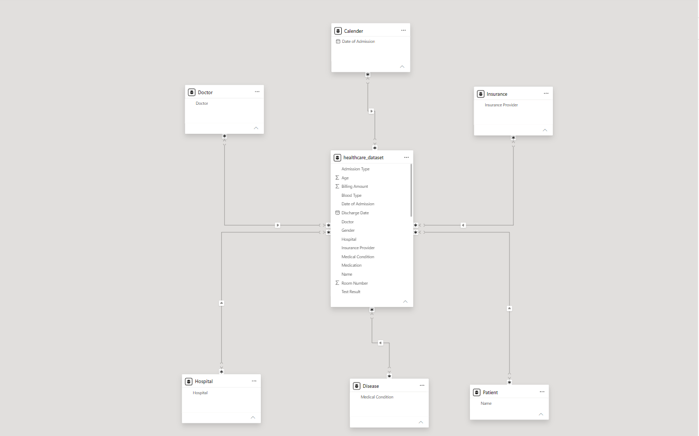Calculated Columns & DAX Measures:
The following DAX measures were implemented to power the KPI cards and charts. (Formulas below follow the standard DAX pattern for each measure name found in the report; verify against the .pbix in Power BI Desktop if you need the exact saved syntax.)
Measure Name | DAX Logic (pattern used)
Total Patients | COUNTROWS(healthcare_dataset)
Average Age | AVERAGE(healthcare_dataset[Age])
Average Billing Amount | AVERAGE(healthcare_dataset[Billing Amount])
Total Hospitals | DISTINCTCOUNT(healthcare_dataset[Hospital])
Total Doctors | DISTINCTCOUNT(healthcare_dataset[Doctor])
Insurance Providers | DISTINCTCOUNT(healthcare_dataset[Insurance Provider])
Admission Type (count) | DISTINCTCOUNT(healthcare_dataset[Admission Type])
Male Count / Female Count | CALCULATE(COUNTROWS(healthcare_dataset), healthcare_dataset[Gender] = "Male"/"Female")
Blood Group measures (A+, A-, B+, B-, AB+, AB-, O+, O-) | CALCULATE(COUNTROWS(healthcare_dataset), healthcare_dataset[Blood Type] = "<group>")
Test Normal / Test Abnormal / Test Inconclusive | CALCULATE(COUNTROWS(healthcare_dataset), healthcare_dataset[Test Results] = "<result>")

8. Analysis and Visualizations (Power BI)
Dashboard Features:
The report is built as a single, consolidated dashboard page ('Healthcare Patient Records Database') combining KPI cards, charts, and a dedicated filter panel:
Visual | Type | Fields / Purpose
KPI Cards (7) | Card | Total Patients, Average Age, Total Hospitals, Total Doctors, Average Billing Amount, Insurance Providers, Admission Type count
Gender Distribution | Pie Chart | Male Count vs. Female Count
Medical Condition | Column Chart | Total Patients by Medical Condition
Admission Type | Column Chart | Total Patients by Admission Type
Billing Amount by Hospital | Bar Chart | Sum of Billing Amount by Hospital
Insurance Provider | Column Chart | Total Patients by Insurance Provider
Blood Group Distribution | Donut Chart | Patient count by each blood group (A+, A-, B+, B-, AB+, AB-, O+, O-)
Test Result | Pie Chart | Normal, Abnormal and Inconclusive test outcomes
Monthly Admissions | Line Chart | Total Patients trended by Month (Date of Admission hierarchy)
Filters Panel | Slicers (7) | Insurance Provider, Gender, Hospital, Doctor, Admission Type, Medical Condition, Date of Admission

- Interactivity: The report uses slicers (Insurance Provider, Gender, Hospital, Doctor, Admission Type, Medical Condition, Date of Admission) so every chart and card responds interactively to the selected filters.
- Titles & Labels: Each visual has a clear, labelled title (e.g. Gender Distribution, Blood Group Distribution, Monthly Admissions) with icons used on KPI cards for quick visual identification.
- Consolidated Report: All visuals are laid out on one consolidated dashboard page for a complete, at-a-glance view of hospital patient activity.

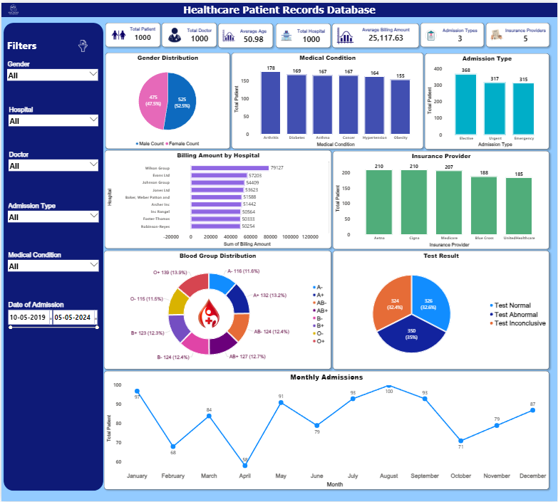

9. Insights & Conclusions
Key Findings:
- Patient volume is fairly evenly split by gender (256 Male vs. 243 Female in the sample data).
- Diabetes (92 patients) and Cancer/Hypertension (85 each) are the most common medical conditions recorded.
- Elective admissions (200) outnumber Urgent (159) and Emergency (140) cases.
- Average billing amount across all patients is approximately $25,012, with a wide spread from a data-quality outlier (one negative value) up to over $51,500.
- Insurance coverage is broadly balanced across the five providers, with UnitedHealthcare and Medicare marginally the most represented.
- Test results are almost evenly distributed between Normal, Abnormal, and Inconclusive outcomes.

Analysis Insights:
- Descriptive: KPI cards and distribution charts summarise current patient volumes, demographics, and billing levels.
- Diagnostic: Cross-filtering by hospital, doctor, and condition helps surface where higher billing or admission volumes originate.
- Predictive: Monthly admission trends can be used to anticipate upcoming patient load and staffing needs.
- Prescriptive: Insights on high-cost hospitals/conditions and admission-type mix can guide resource allocation and insurance negotiation strategies.

10. Conclusion
The integration of Excel and Power BI proved effective for end-to-end analysis of hospital patient records — from raw data cleaning through to a consolidated, interactive dashboard. The resulting report gives healthcare stakeholders a single view of patient demographics, medical conditions, billing performance, and admission trends to support faster, more informed operational decisions.

